**Visvesvaraya Technological University**

**Belagavi-590 018, Karnataka**



A Mini Project Report on

**“BLISS: DTH DATABASE”**

**Mini** **Project Report submitted in partial fulfilment of the requirement for the**

**Database Applications Lab [17CSL58]**

**Bachelor of Engineering**

**in**

**Computer Science and Engineering**

**Submitted by**

**Shreyas Nadig [1JT17CS042]**

**Surya G [1JT17CS050]**



**Department of Computer Science and Engineering**

**Jyothy Institute of Technology**

**Tataguni, Bengaluru-560082**

**Jyothy Institute of Technology**

**Tataguni, Bengaluru-560082**

**Department of Computer Science and Engineering**



**CERTIFICATE**

Certified that the mini project work entitled **“Music Streaming Database”** carried out by **Shreyas Nadig [1JT17CS042] & Surya G [1JT17CS050]** Bonafide student of Jyothy Institute of Technology, in partial fulfilment for the award of **Bachelor of Engineering** in **Computer Science and Engineering** department of the **Visvesvaraya Technological University, Belagavi** during the year **2019-2020**. It is certified that all corrections/suggestions indicated for Internal Assessment have been incorporated in the Report deposited in the departmental library. The project report has been approved as it satisfies the academic requirements in respect of Project work prescribed for the said Degree.

**Dr. Prabhanjan S**

Professor and HOD

Dept. of CSE

External Viva Examiner Signature with Date:

**ACKNOWLEDGEMENT**

Firstly, we are very grateful to this esteemed institution **“Jyothy Institute of Technology**” for providing us an opportunity to complete our project.

We express our sincere thanks to our Principal **Dr. Gopalakrishna K** for providing us with adequate facilities to undertake this project.

We would like to thank **Dr. Prabhanjan S** Professor and Headof Computer Science and Engineering Department for providing for his valuable support.

We would like to thank our guides **Mrs.Nikitha S,** Asst. Prof**. and Dr.Prabhanjan S** Porf.HOD for their keen interest and guidance in preparing this work.

Finally, we would thank all our friends who have helped us directly or indirectly in this project.

**Shreyas Nadig[1JT17CS042]**

**Surya G[1JT17CS050]**

**ABSTRACT**

“In this mini project we have created one application which is easy to access and user friendly. For this application we used the backend as SQL to store the data which is used in the application and for the user interface, we have used JAVA. The users are able to access this application. The purpose of this application is for smooth streaming and to get a brief idea of overall working and methodology of DTH services. The application keeps a backup of the DTH data which includes the admin details, customer details, set-top box details and the packages they offer.

The use of DTH service is rapidly increasing in India and other countries; the manual maintenance DTH connection information by admin is very strenuous and also consumes a lot of time. For this reason, an efficient system is to be proposed to ease the issue of DTH management system. The proposed system is a desktop - based application that allows admin to manage setup box, package, customer and payment details.

**Table of Contents**

|  |  |  |
| --- | --- | --- |
| **SL No** | **Description** | **Page No.** |
| 1 | INTRODUCTION | 6 |
| 2 | DESIGN | 9 |
| 3 | IMPLEMENTATION | 12 |
| 4 | RESULTS AND SNAPSHOTS | 17 |
| 5 | CONCLUSION | 30 |

***CHAPTER 1***

***INTRODUCTION***

1. **INTRODUCTION**

**1.1 Introduction to DBMS**

A database is simply an organized collection of related data, typically stored on disk, and accessible by possibly many concurrent users. Databases are generally separated into application areas. For example, one database may contain Human Resource (employee and payroll) data; another may contain sales data; another may contain accounting data; and so on. Databases are managed by a DBMS.

The choice of a database product is often influenced by factors such as:

the computing platform (i.e., hardware, operating system)

* the volume of data to be managed
* the number of transactions required per second
* existing applications or interfaces that an organization may have
* support for heterogeneous and/or distributed computing
* cost
* vendor support

**1.2 Introduction to SQL**

[**SQL**](https://en.wikipedia.org/wiki/SQL), which is an abbreviation for **Structured Query Language**, is a language to request data from a database, to add, update, or remove data within a database, or to manipulate the metadata of the database.

SQL is a declarative language in which the expected result or operation is given without the specific details about how to accomplish the task. The steps required to execute SQL statements are handled transparently by the SQL database. Sometimes SQL is characterized as non*-*proceduralbecause procedural languages generally require the details of the operations to be specified, such as opening and closing tables, loading and searching indexes, or flushing buffers and writing data to file systems. Therefore, SQL is considered to be designed at a higher conceptual level of operation than procedural languages because the lower level logical and physical operations aren't specified and are determined by the SQL engine or server process that executes it.

**1.3 Introduction to DTH Service Database**

The first DTH service in India was introduced in 2003 by Dish TV. In 2004 Prasar Bharati lunched free DTH service. In terms of number of subscribers, India became the largest DTH market. DTH telecasting is a method of receiving signals transmitted from direct-broadcast-satellites.

This project of using technology in DTH fields for administration, customer records, set-top box details, and package fields. This project was prepared for using computerized programs for the above fields. According to the basic needs of programs for this DTH services, this project was prepared to make the works easier.

**1.4 Scope and importance of work**

The scope of the project is clear to give a simple and attractive application to simplify the work as well as to reduce the efforts while doing it offline or we can say by doing it with old methods.

In this application we are able to save the database of all the admins, customers, set-top boxes and package details.

The admin data includes the admin id, name and their location of work, the customer data includes customer name, phone and email, set-top data includes the serial number of the et-top box, it type, cost and the date it was purchased and added, and package details contains the packages chosen by the customer and cost of each such package.

***CHAPTER 2***

***DESIGN***

Theory of ER Diagram

An **entity relationship diagram** (**ERD**) shows the relationships of entity sets stored in a database. ... By defining the entities, their attributes, and showing the relationships between them, an **ER diagram** illustrates the logical structure of databases. **ER diagrams** are used to sketch out the design of a database.

ER Diagram

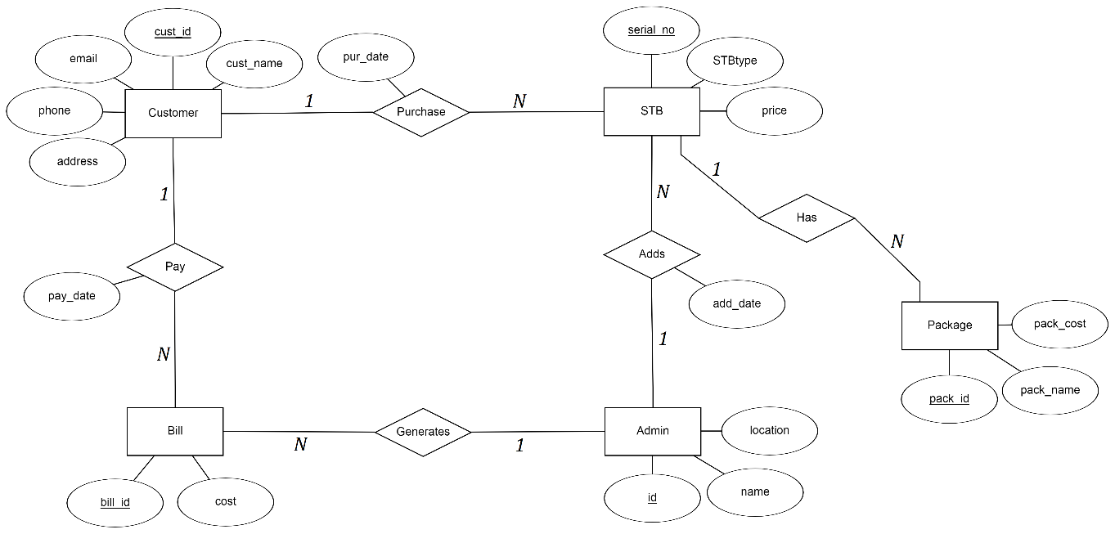

Schema Diagram

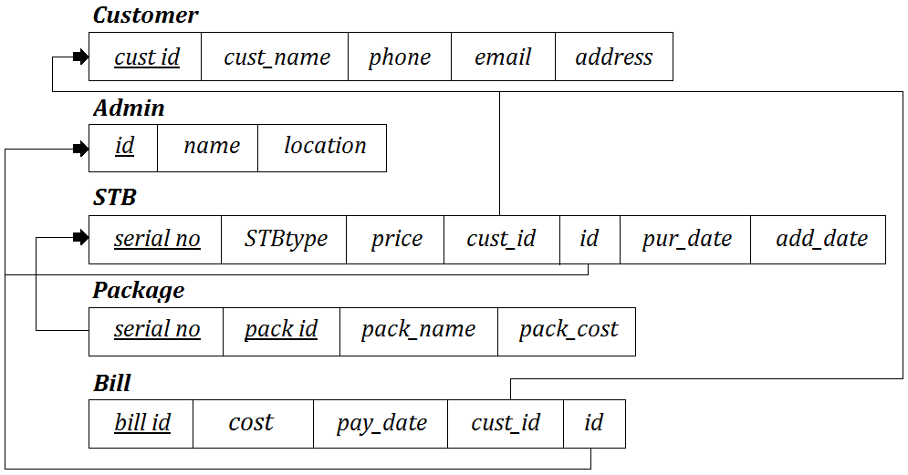

List of Tables

1. Admin
2. Customer
3. Set-Top Box
4. Package
5. Bill

***CHAPTER 3***

***IMPLEMENTATION***

**Create tables commands, Insert, DESC of tables**

create table customer(cust_id int primary key, cust_name varchar(30), phone varchar(10) unique not null, email varchar(30), address varchar(30),password varchar(30));

create table admin(id int primary key, name varchar(30), location varchar(30),password varchar(30));

create table STB(serial_no int primary key, STBtype varchar(30), price int, cust_id int, id int, pur_date date, add_date date, foreign key(cust_id) references customer(cust_id) on delete cascade on update cascade, foreign key(id) references admin(id) on delete cascade on update cascade);

create table package(serial_no int, pack_id int, pack_name varchar(30), pack_cost int, primary key(serial_no, pack_id), foreign key(serial_no) references STB(serial_no) on delete cascade on update cascade);

create table bill(bill_id int primary key, cost int, pay_date date, cust_id int, id int, foreign key(cust_id) references customer(cust_id) on delete cascade on update cascade, foreign key(id) references admin(id) on delete cascade on update cascade);

**Trigger**

(The trigger that is being using, is to automatically set the price of the Setup box when the type of the setup box is specified.)

delimiter $$

create trigger upd_price before insert on stb

for each row

begin

if new.STBtype = 'SD' then

set new.price = 1099;

elseif new.STBtype = 'HD' then

set new.price = 1299;

elseif new.STBtype = '4K' then

set new.price = 6400;

elseif new.STBtype = '+HD' then

set new.price = 9300;

end if;

end; $$

delimiter ;

**Stored Procedure**

(This stored procedure calculates the total cost of all the packages selected by the customer.)

delimiter $$

create procedure calbill(in phone varchar(30))

begin

update bill set cost =(select sum(p.pack_cost) from customer c, stb s, bill b, package p where c.cust_id=s.cust_id and b.cust_id=c.cust_id and s.serial_no=p.serial_no and c.phone=phone) where bill_id=(select b.bill_id from bill b,customer c where c.cust_id=b.cust_id and c.phone=phone);

end $$

delimiter ;

**Insertion of admin table**

insert into admin values(101,'Advik','Bengaluru','123456');

insert into admin values(102,'Yuvan','Mumbai','123456');

insert into admin values(103,'Raaj','Delhi','123456');

insert into admin values(104,'Garv','Bengaluru','123456');

insert into admin values(105,'Dhruv','Chennai','123456');

insert into admin values(106,'Ishan','Delhi','123456');

insert into admin values(107,'Daksh','Chennai','123456');

insert into admin values(108,'Vrushti','Mumbai','123456');

insert into admin values(109,'Tanya','Pune','123456');

insert into admin values(110,'Tiya','Kolkata','123456');

insert into admin values(111,'Sejal','Bengaluru','123456');

insert into admin values(112,'Jiya','Bengaluru','123456');

insert into admin values(113,'Vedant','Mumbai','123456');

insert into admin values(114,'Anya','Kolkata','123456');

insert into admin values(115,'Myra','Pune','123456');

**Insertion of Customer table**

insert into customer values(501,'Liyan','9853454120','liyan.joesph@gmail.com','Kolkata','qwerty');

insert into customer values(502,'Zayant','9912876120','zayant02@gmail.com','Bengaluru','qwerty');

insert into customer values(503,'Bhavya','7429864831','bhavya.gowda@gmail.com','Bengaluru','qwerty');

insert into customer values(504,'Pranay','7489648105','pranay123@gmail.com','Chennai','qwerty');

insert into customer values(505,'Aditi','6478123544','aditinarayan@gmail.com','Mumbai','qwerty');

insert into customer values(506,'Satvik','7848415826','satvik.sharma@gmail.com','Delhi','qwerty');

insert into customer values(507,'Tanay','87451234478','tanaybaptist@gmail.com','Mumbai','qwerty');

insert into customer values(508,'Uchit','9987481231','uchitmeanscorrect@gmail.com','Delhi','qwerty');

insert into customer values(509,'Ishita','8812385233','ishita.kaira@gmail.com','Pune','qwerty');

insert into customer values(510,'Iniya','9853454170','iniya.ved@gmail.com','Bengaluru','qwerty');

**Insertion of STB table**

insert into stb(serial_no,STBtype,cust_id,id,pur_date,add_date) values(1001,'HD',501,110,'2019-09-01','2019-09-02');

insert into stb(serial_no,STBtype,cust_id,id,pur_date,add_date) values(1002,'4K',502,101,'2019-09-02','2019-09-05');

insert into stb(serial_no,STBtype,cust_id,id,pur_date,add_date) values(1003,'SD',503,111,'2019-09-05','2019-09-05');

insert into stb(serial_no,STBtype,cust_id,id,pur_date,add_date) values(1004,'HD',504,107,'2019-09-06','2019-09-06');

insert into stb(serial_no,STBtype,cust_id,id,pur_date,add_date) values(1005,'4K',505,102,'2019-09-10','2019-09-11');

insert into stb(serial_no,STBtype,cust_id,id,pur_date,add_date) values(1006,'SD',506,106,'2019-09-12','2019-09-12');

insert into stb(serial_no,STBtype,cust_id,id,pur_date,add_date) values(1007,'HD',507,102,'2019-09-15','2019-09-18');

insert into stb(serial_no,STBtype,cust_id,id,pur_date,add_date) values(1008,'HD',508,103,'2019-09-17','2019-09-17');

insert into stb(serial_no,STBtype,cust_id,id,pur_date,add_date) values(1009,'+HD',509,109,'2019-09-20','2019-09-25');

insert into stb(serial_no,STBtype,cust_id,id,pur_date,add_date) values(1010,'4K',510,101,'2019-09-22','2019-09-28');

**Insertion of package table**

insert into package values(1001,8,'English Movies',150);

insert into package values(1001,9,'English Entertainment',120);

insert into package values(1002,1,'Kannada Movies',200);

insert into package values(1002,8,'English Movies',175);

insert into package values(1003,1,'Kannada Movies',100);

insert into package values(1003,7,'Kannada Music',75);

insert into package values(1004,9,'English Entertainment',120);

insert into package values(1004,14,'English Music',120);

insert into package values(1005,16,'Hindi Entertainment',170);

insert into package values(1005,18,'Hindi Lifestyle',170);

insert into package values(1006,12,'English News',100);

insert into package values(1006,21,'Hindi Music',75);

insert into package values(1007,10,'English Sports',150);

insert into package values(1007,15,'Hindi Movies',150);

insert into package values(1008,11,'English Lifestyle',120);

insert into package values(1008,15,'Hindi Movies',150);

insert into package values(1009,10,'English Lifestyle',170);

insert into package values(1009,13,'English Kids',200);

insert into package values(1010,14,'English Music',150);

insert into package values(1010,18,'Hindi Lifestyle',100);

**Insertion of Bill table**

insert into bill(bill_id,pay_date,cust_id,id) values(5001,'2019-10-02',501,110);

insert into bill(bill_id,pay_date,cust_id,id) values(5002,'2019-10-05',502,101);

insert into bill(bill_id,pay_date,cust_id,id) values(5003,'2019-10-05',503,111);

insert into bill(bill_id,pay_date,cust_id,id) values(5004,'2019-10-06',504,107);

insert into bill(bill_id,pay_date,cust_id,id) values(5005,'2019-10-11',505,102);

insert into bill(bill_id,pay_date,cust_id,id) values(5006,'2019-10-12',506,106);

insert into bill(bill_id,pay_date,cust_id,id) values(5007,'2019-10-18',507,102);

insert into bill(bill_id,pay_date,cust_id,id) values(5008,'2019-10-17',508,103);

insert into bill(bill_id,pay_date,cust_id,id) values(5009,'2019-10-25',509,109);

insert into bill(bill_id,pay_date,cust_id,id) values(5010,'2019-10-28',510,101);

call calbill(9853454120);

call calbill(9912876120);

call calbill(7429864831);

call calbill(7489648105);

call calbill(6478123544);

call calbill(7848415826);

call calbill(8745123447);

call calbill(9987481231);

call calbill(8812385233);

call calbill(9853454170);

***CHAPTER 4***

***RESULTS AND SNAPSHOTS***

**Select * from Tables, Queries snapshots, Front end snapshots**

* 1. Select * from admin;

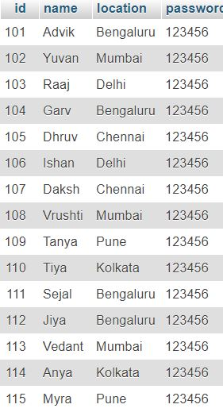

* 1. Select * from customer;

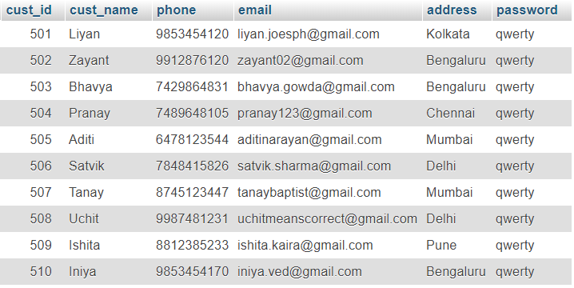

* 1. Select * from stb;

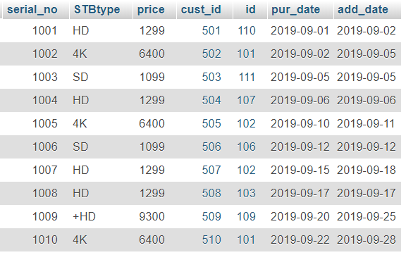

4. Select * from package;

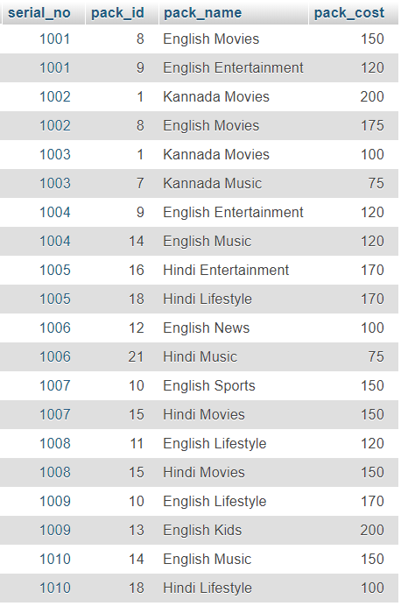

5. Select * from Bill;

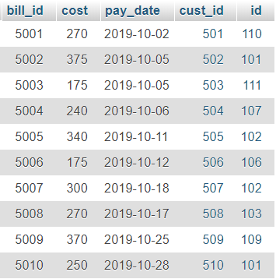

**Queries**

1. List the details from stb table who have 4K set top box.

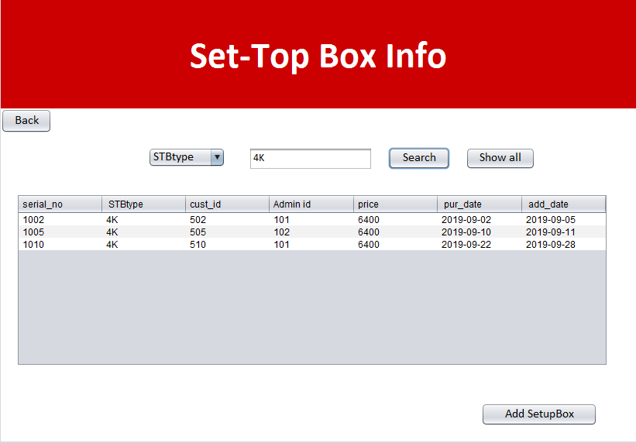

2. Display ‘My Account’ details of user whose phone number = ‘9987481231’.

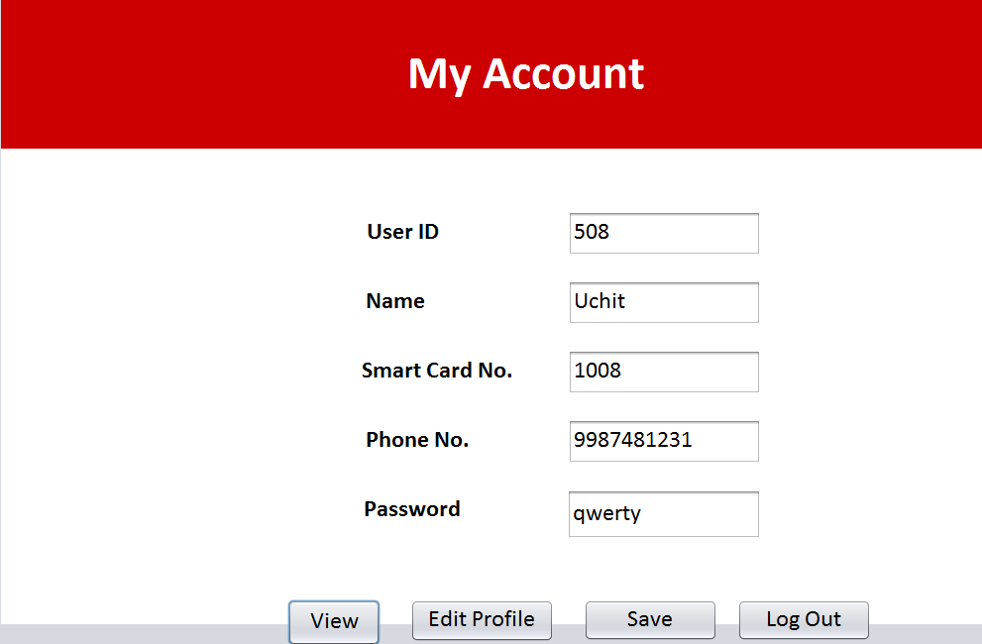

3. List all the packages selected by the customer whose phone = ‘7429864831’.

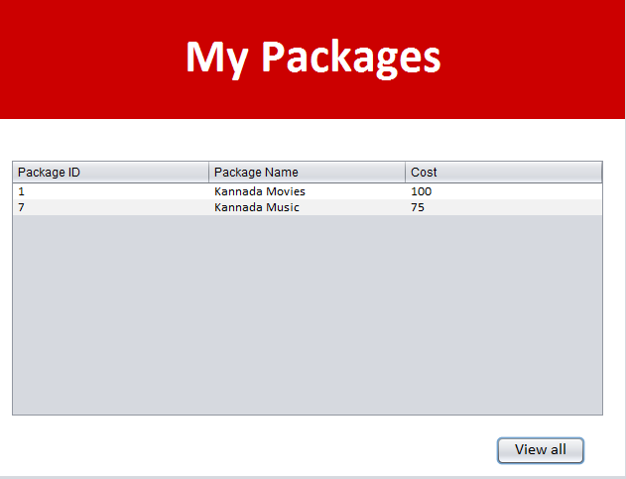

4. Display all the details of the admins who are from the location ‘Bengaluru’.

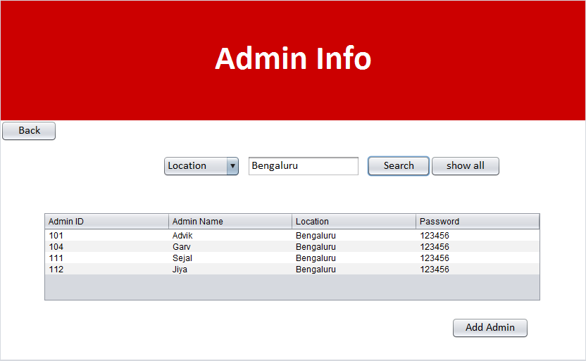

5. Display all the bills payable before 20th of a month.

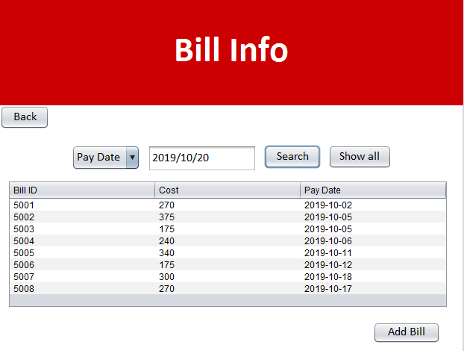

6. Show the credentials and calculate bill amount payable by a person whose name is ‘Liyan’.

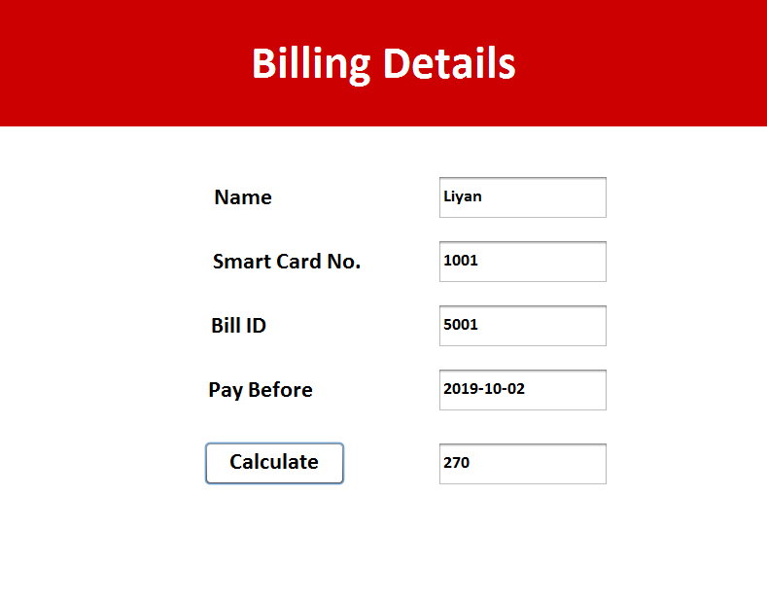

7. Show the stb table after the trigger has been used.

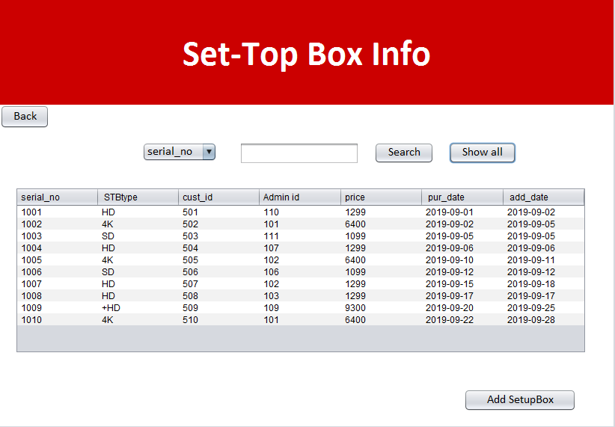

8. Sort the packages in increasing order of their price.

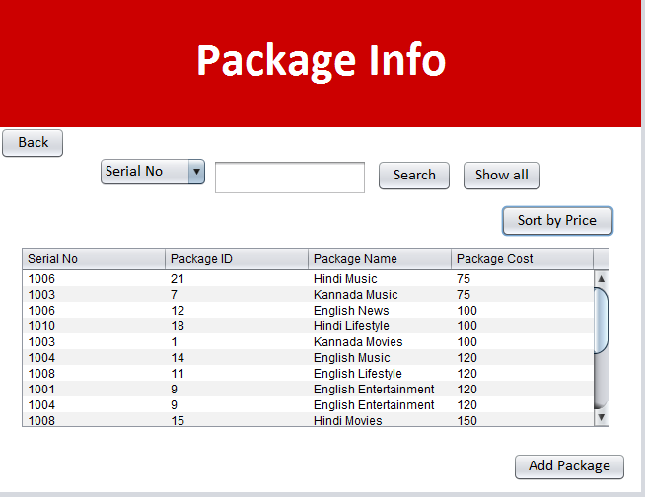

**Conclusion**

The total number of DTH subscribers in India is increasing very rapidly. Admin maintaining the information manually is a tedious job. This undertaking intended to meet requirements of a DTH management system. Several steps have been performed to construct the desktop application, the work mainly consisted of using ready-made libraries, modifying existing open source projects and writing codes from scratch. Development platform that was used is netbeans 8.2.

It has been developed in Java and database has been built in MySQL. By using this application, the admin can manage setup boxes, packages, customers and payments details. It is designed for use by the Admin to internally manage their business processes, minimizing human errors and overcoming difficulties and problems that arose in the previous system.

**Limitations**

However, the system still suffers some limitations such a

* Developing web application with separate dashboard for admin and users/customers.

**Future Works**

The application can be enhanced by so many extra features. Some of these features can be summarized as follows

* Improving the UI, because the user interface can always be improved.
* Developing web application with separate interface for users/customers.
* Developing mobile application, since it is more easy to use.

**References**

***Websites***

* [*www.w3schools.com*](http://www.w3schools.com)
* [*www.codecademy.com/learn/learn-java*](http://www.codecademy.com/learn/learn-java)
* *udemy.com*
* *Google*
* *Wikipedia*

***Books***

* Fundamentals of DATABASE SYSTEMS by NAVATHE
* The complete References Java